This is what you’ll be creating:

Step 01
Create a 255 by 255px document. First, enable the Grid (View > Show Grid) and the Snap to Grid (View > Snap to Grid). Next, you’ll need a grid every 5px. Go to Edit > Preferences > Guides > Grid, enter 5 in the Gridline every box and 1 in the Subdivisions box. You can also open the Info panel (Window > Info) for a live preview with the size and position of your shapes. Do not forget to replace the unit of measurement to pixels from Edit > Preferences > Unit > General. Al these options will significantly increase your work speed.
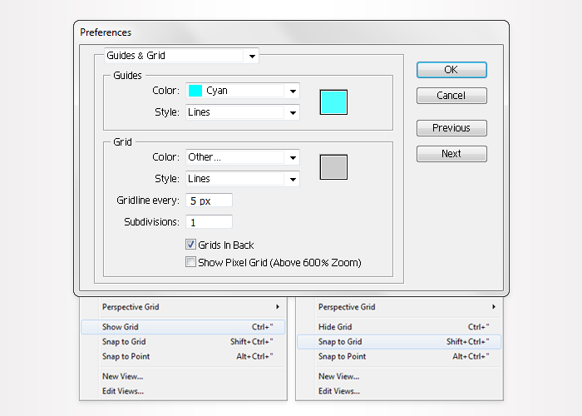
Pick the Ellipse Tool(L) and create a 290 by 410px shape. Fill it with R=25 G=25 B=25 and go to Effect > Warp > Shell Lower. Enter the data shown below, click OK then go to Object > Expand Appearance. Select the resulting shape and lower its opacity to 30%.
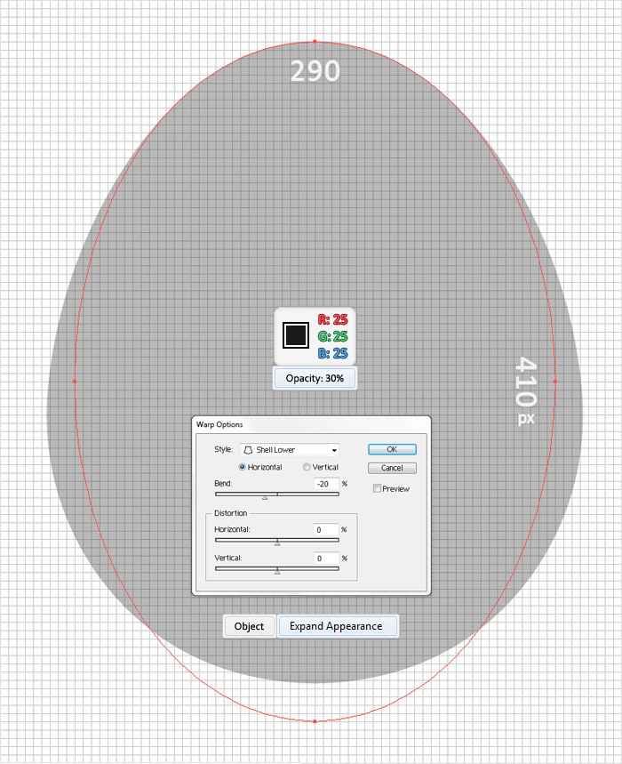
Reselect the Ellipse Tool(L) and create a 210 by 230px shape. Fill it with R=255 G=255 B=245 and place it as shown in the following image.
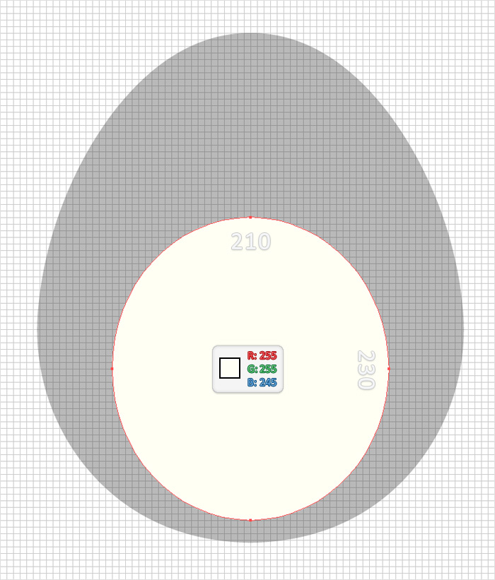
Pick the Ellipse Tool(L), create two 80 by 80px shapes and place them as shown in the following image. Fill them both with R=255 G=255 B=245 and go to Effect > Warp > Shell Lower. Enter the data shown below, click OK and go to Object > Expand Appearance.
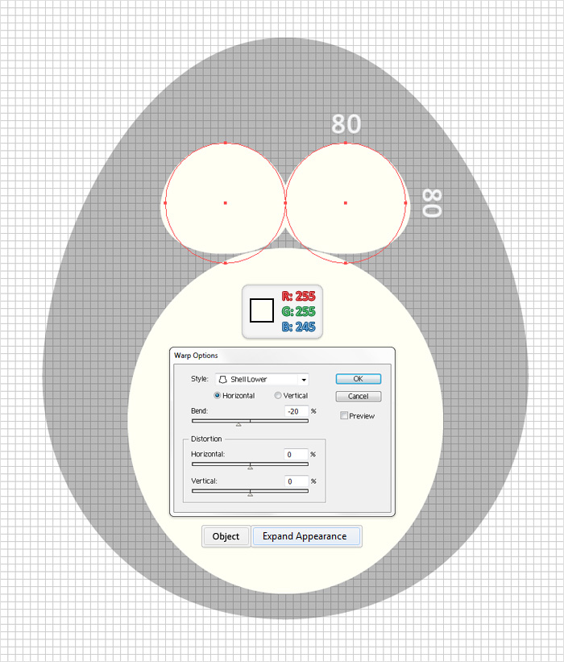
Keep focusing on the shapes created in the previous step. Select the left shape and go to Object > Transform > Rotate. Enter a 45 degrees angle and click OK then select the right shape and go to Object > Transform > Rotate. Enter a -45 degrees angle and click OK. Reselect both shapes and click on the Unite button from the Pathfinder panel then move the resulting shape as shown in the third image. Once again the Snap to Grid will ease your work.
Pick the Ellipse Tool(L) and create a small shape. Fill it with R=255 G=255 B=245 and place it as shown in the first image. Select this small shape along with the other two shapes filled with R=255 G=255 B=245 and click on the Unite button from the Pathfinder panel.
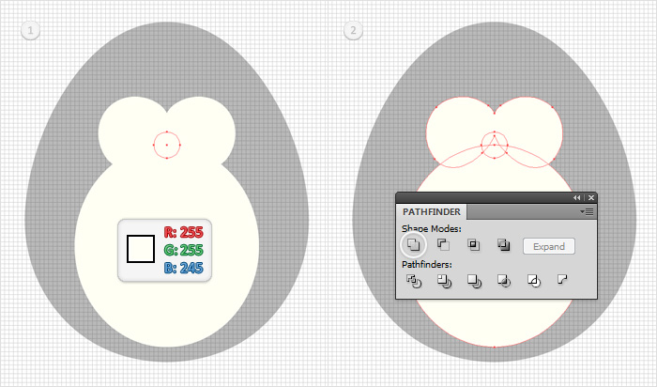
Select the shape created in the previous step and go to Object > Path > Offset Path. Enter a -5px Offset and click OK. Fill the resulting shape with the linear gradient shown below, lower its opacity to 20% and go to Effect > Blur > Gaussian Blur. Enter a 15px radius then click OK. The yellow zero from the gradient image stands for opacity percentage.
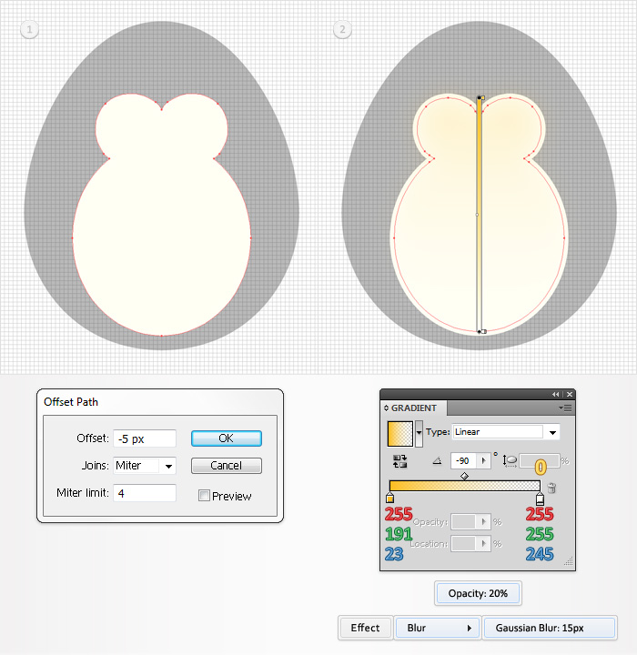
Again, select the shape created in the previous step and go to Object > Path > Offset Path. Enter a -5px Offset and click OK. Select the resulting shape and go to the Appearance panel. First, remove the Gaussian Blur effect then fill it with the linear gradient shown below and lower its opacity to 5%.
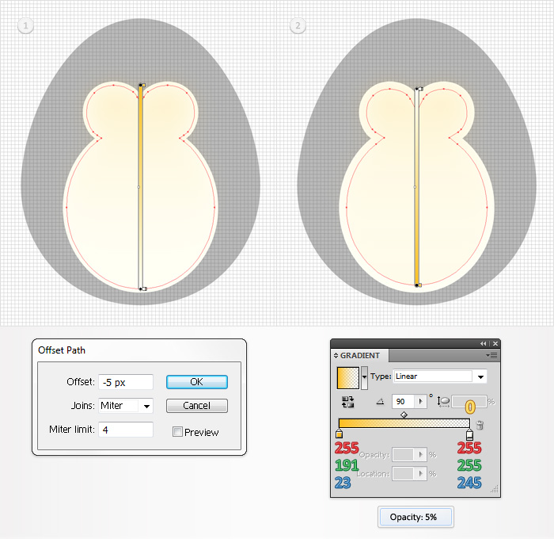
Pick the Ellipse Tool(L), create a 70 by 190px shape and fill it with the linear gradient shown below. Select this fresh shape and go to Object > Transform > Rotate. Enter a -14 degrees angle and click OK.
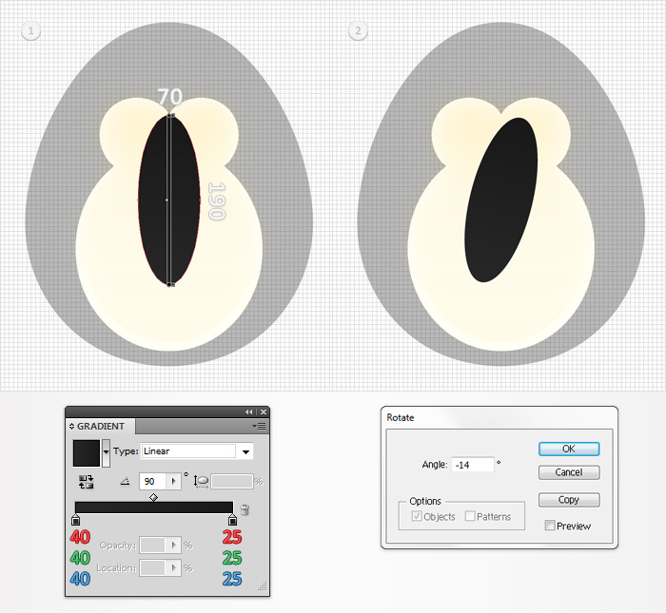
Select the shape created in the previous step, place it as shown in the following image and make two copies in front (Control + C > Control + F > Control + F). Select the top copy and hit the up arrow once (to move it 5px up). Reselect both copies and click on the Minus Front button from the Pathfinder panel. Fill the resulting shape with R=65 G=64 B=66.
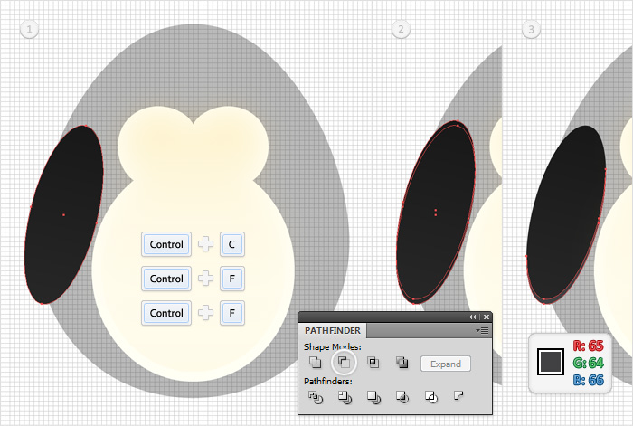
Select the two shapes created in the previous two step and group them. Select this new group and go to Object > Transform > Reflect. Check the Vertical button then click on the Copy button. This will create a horizontally flipped copy of the selected group. Select it and move it to the right as shown in the third image.
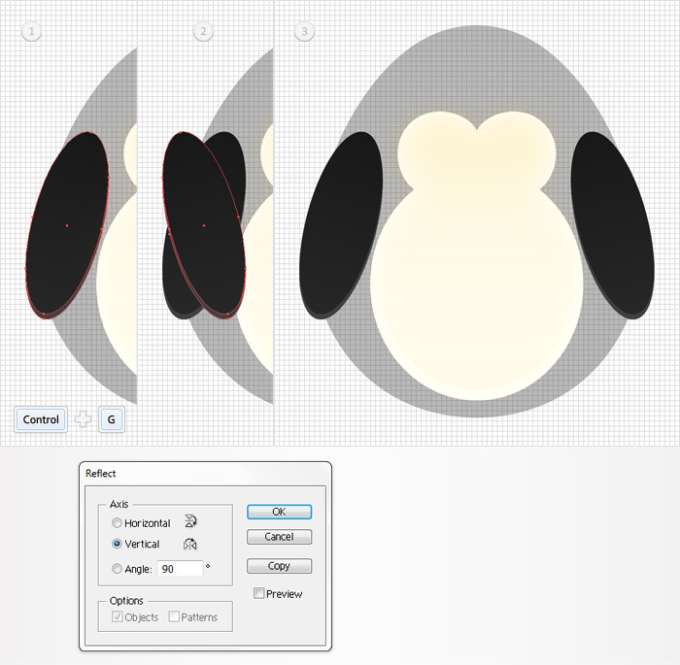
Pick the Ellipse Tool(L), create a 20 by 20px shape and fill it with black. Continue with the Ellipse Tool(L) and create a 5 by 5px shape. Fill it with white and place it as shown in the first image. Switch to the Rectangle Tool(M) and create a 20 by 5px shape. Fill it with black then go to Object > Transform > Rotate. Enter a -17 degrees angle then click OK. Select this rotate shape and place it as shown in the fourth image. Once again, the Snap to Grid will ease your work.
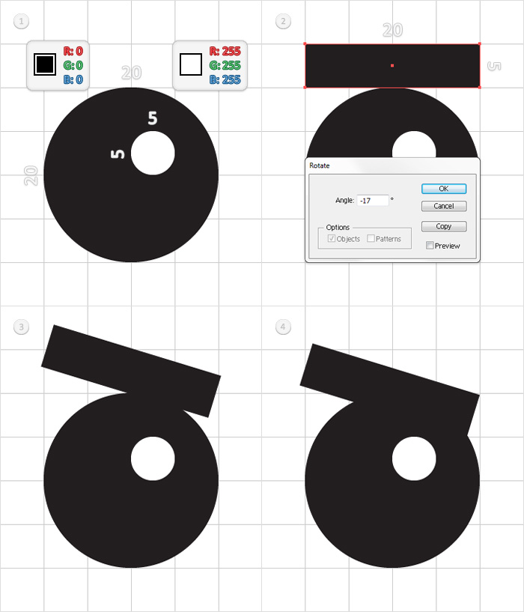
Select the three shapes created in the previous step and group them (Control + G). Select this new group and go to Object > Transform > Reflect. Check the Vertical button then click on the Copy button. This will create a horizontally flipped copy of the selected group. Reselect both groups and place them as shown in the third image.
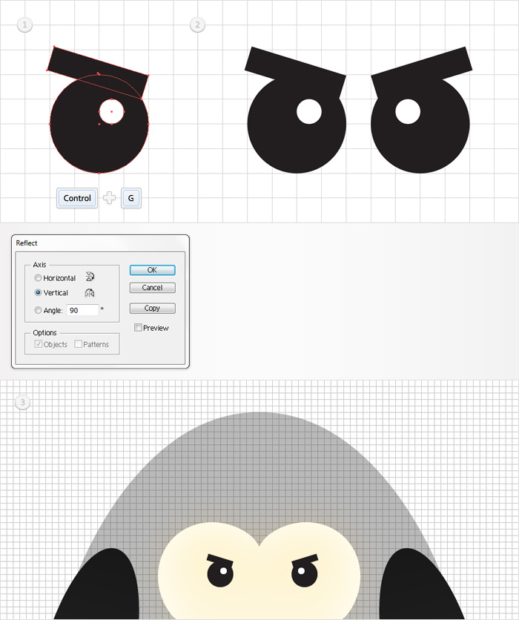
Pick the Ellipse Tool(L), create a 30 by 25px and place it as shown in the following image. Fill it with R=251 G=176 B=64 and go to Effect > Warp > Arc. Enter the data shown below, click OK then go to Object > Expand Appearance.
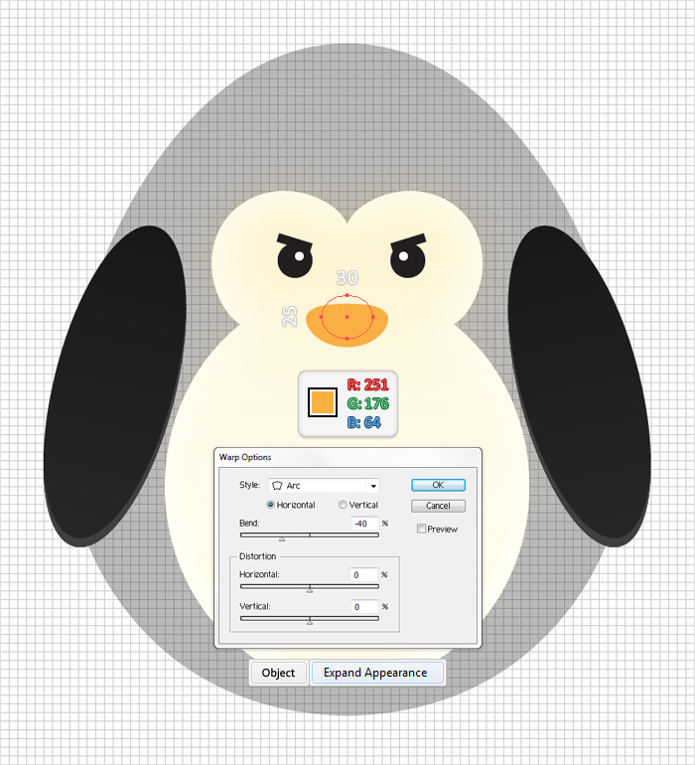
Let’s focus on the shape created in the previous step. Select it and make a copy in front (Control + C > Control + F). Select the copy and hit the up arrow once then select both shapes and click on the Divide button from the Pathfinder panel. This will create a group with three simple shapes. Delete the top shape then select the bottom shape and fill it with R=247 G=148 B=30.
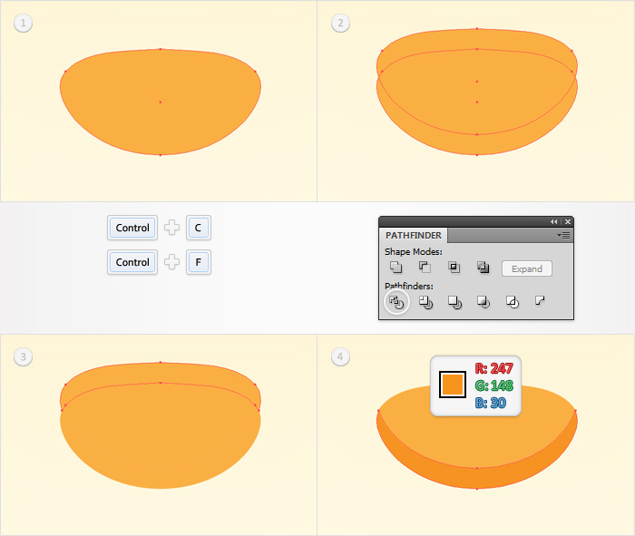
Disable the Snap to Grid (View > Snap to Grid). Select the top, orange shape and make two copies in front (Control + C > Control + F > Control + F). Select the top copy and hit the up arrow once. Reselect both copies and click on the Minus Front button from the Pathfinder panel. Fill the resulting shape with R=255 G=191 B=23.
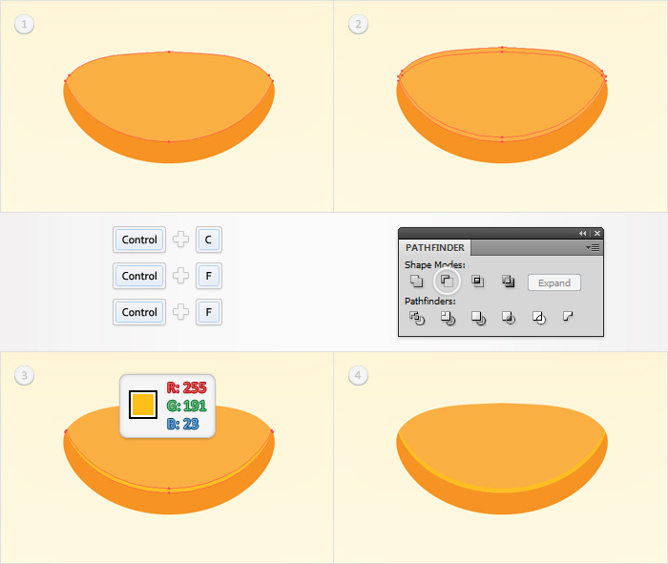
Re-enable the Snap to Grid (View > Snap to Grid). Pick the Ellipse Tool(L),create a 90 by 30px shape and place it as shown below. Fill it with R=251G =176 B=64 and Send it to Back (Shift + Control + [ ).
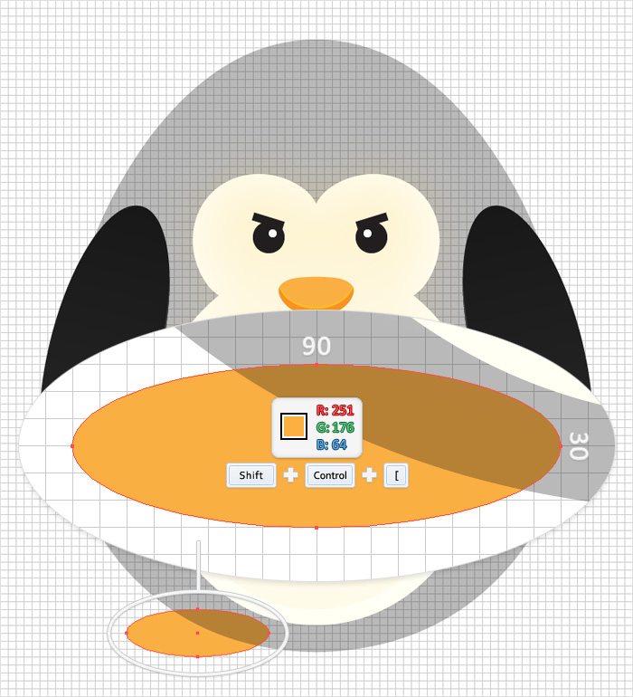
Reselect the shape created in the previous step and go to the Appearance panel. Select the existing fill and click on the Duplicate Selected Item button from the bottom of the Appearance panel. Obviously, this will add a copy of the selected fill. Select it and use the linear gradient shown below.
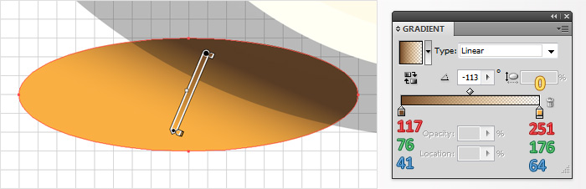
Disable the Snap to Grid (View > Snap to Grid). Select the shape from the previous step and make two copies in front (Control + C > Control + F > Control + F). Select the top copy and hit the up arrow and the right arrow twice. Reselect both copies and click on the Minus Front button from the Pathfinder panel. Fill the resulting shape with the linear gradient shown below.
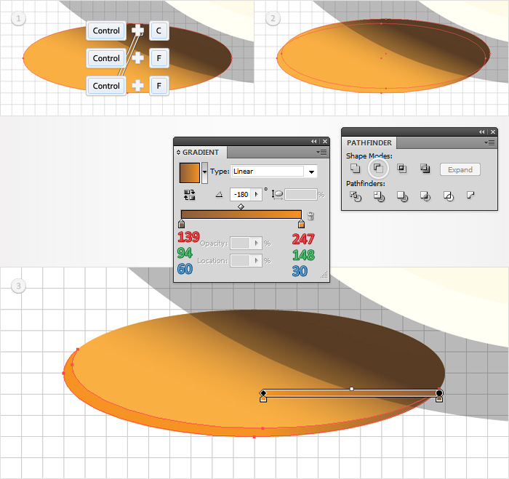
Again, select the shape created in the seventeenth step and make two copies in front (Control + C > Control + F > Control + F). Select the top copy and hit the up arrow and the right arrow three times. Reselect both copies and click on the Minus Front button from the Pathfinder panel. Fill the resulting shape with the linear gradient shown below.
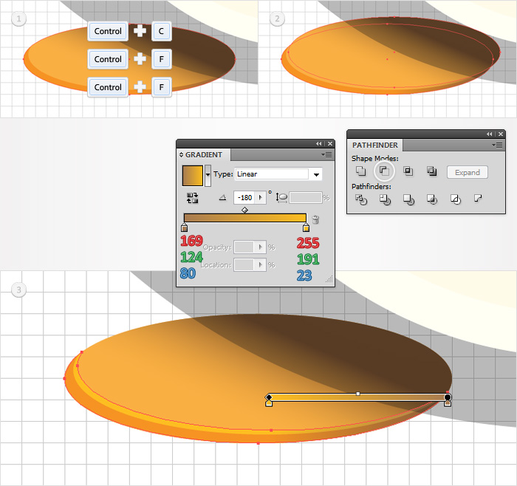
Re-enable the Snap to Grid (View > Snap to Grid). Once again, select the shape created in the seventeenth step and make a copy in front (Control + C > Control + F). Pick the Ellipse Tool(L), create a 120 by 60px shape and place it as shown in the second image. Select it along with the fresh copy and click on the Intersect button from the Pathfinder panel. Fill the resulting shape with black and lower its opacity to 7%.
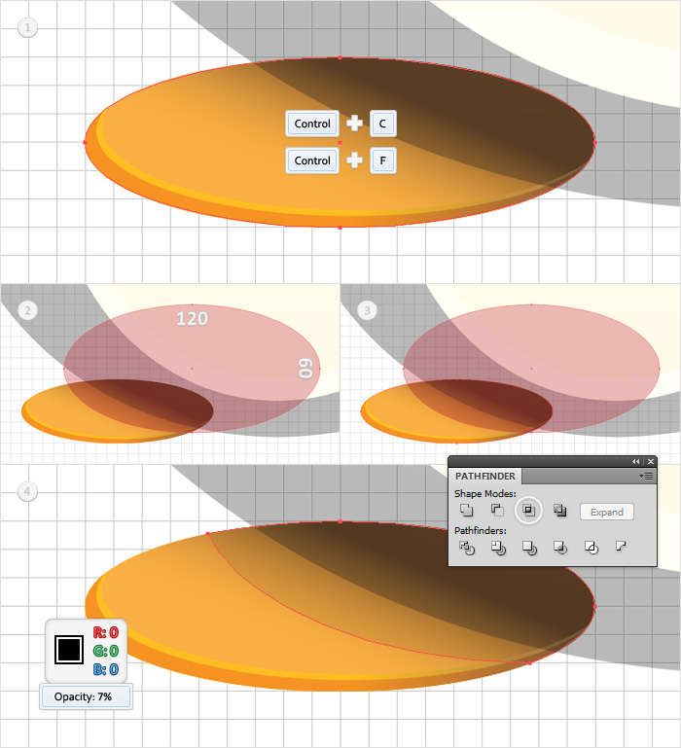
Select the four shapes that make up the foot and group them (Control + G). Select this group, send it to back (Shift + Control + [ ) and go to Object > Transform > Reflect. Check the Vertical button then click on the Copy button. Select the resulting group and move it to the right as shown in the third image.
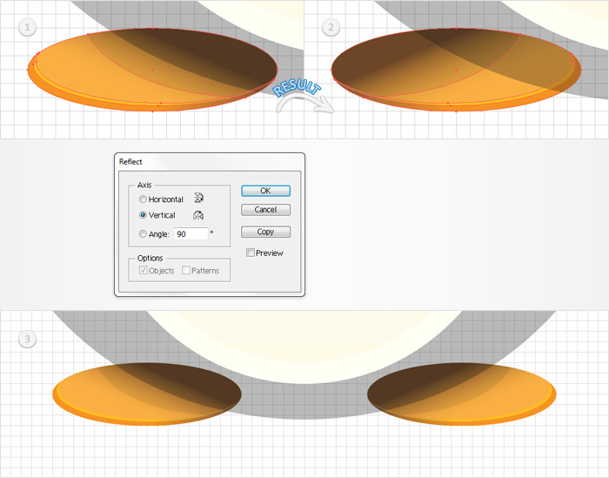
Pick the Ellipse Tool(L) and create a 100 by 40px shape. Fill it with the linear gradient shown below and place it as shown in the following image.
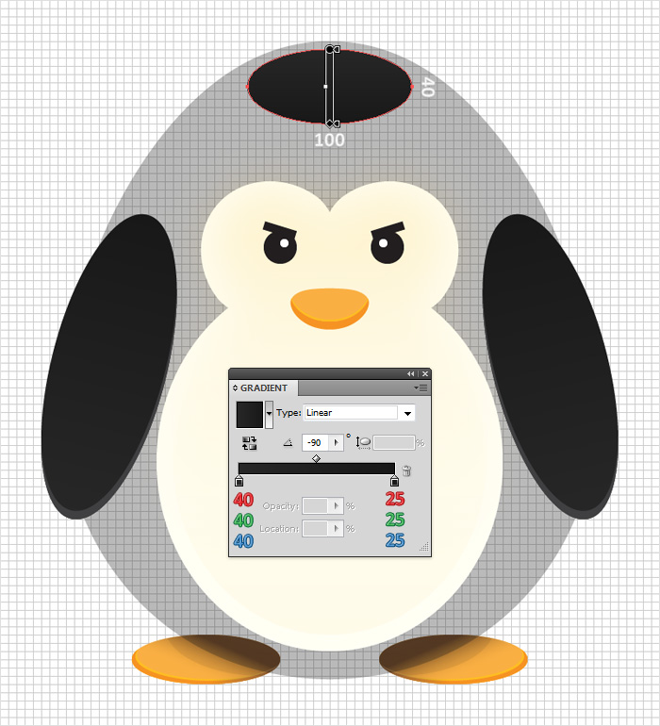
Reselect the shape create in the second step, raise its opacity to 100% and make two copies in front (Control + C > Control + F > Control + F). Select the top copy and hit the up arrow twice. Reselect both copies and click on the Minus Front button from the Pathfinder panel. Fill the resulting shape with black.
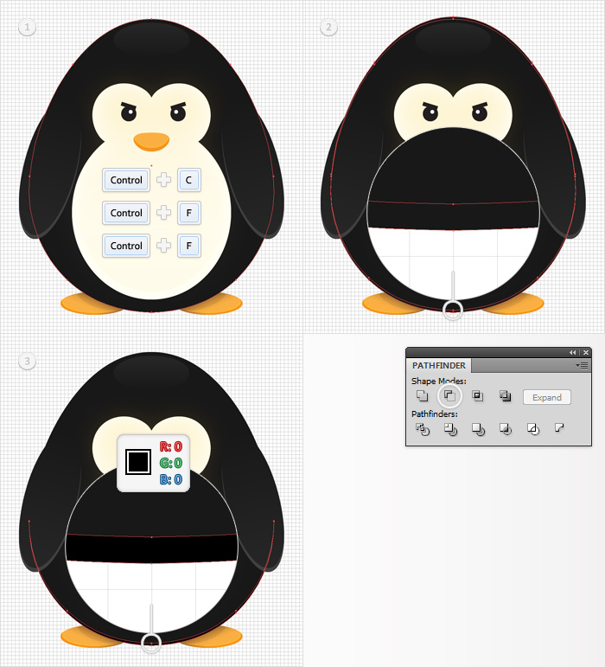
Pick the Ellipse Tool(L), create a 260 by 70px shape and place it as shown in the first image. Fill it with R=195 G=231 B=239 and lower its opacity to 30%. Continue with the Ellipse Tool(L) and create two new shapes. A 310 by 90px shape and a 290 by 80 px shape. Place them as shown in the following images and use the fill color and opacity percentage.
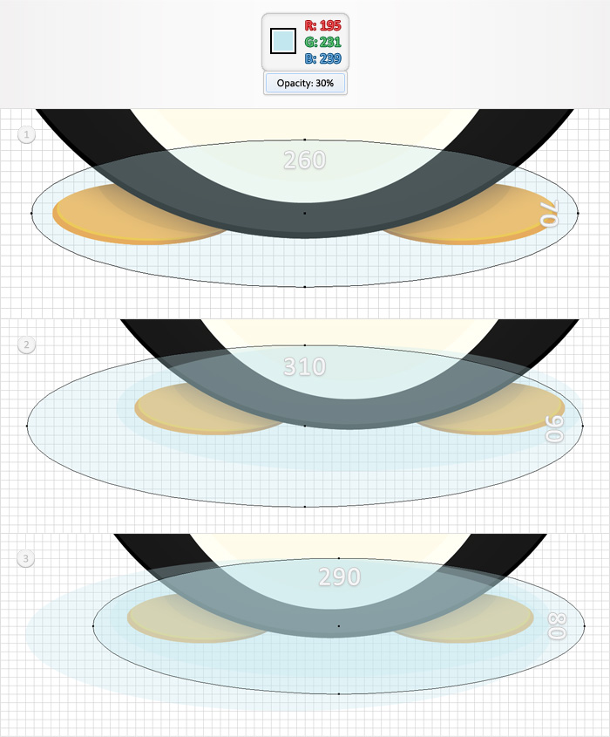
Select the three shapes created in the previous step and group them (Control + G). Send this new group to back (Shift + Control + [ ).
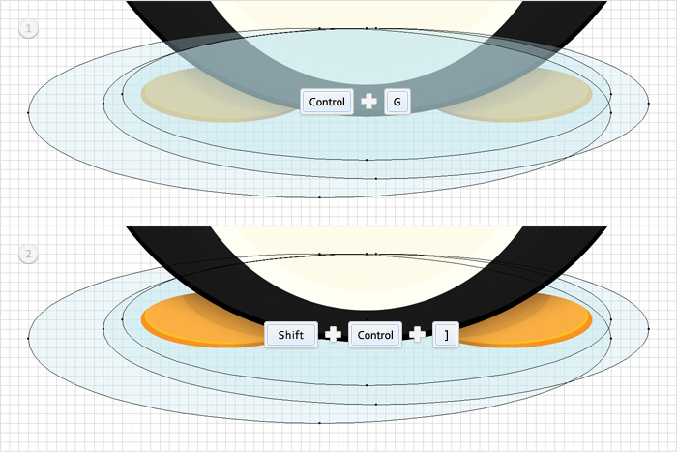
Finally, for the background use the Rectangle Tool(M). Create a shape the size of your artboard and fill it with R=255 G=255 B=245. Add a second fill for this shape and use the radial gradient shown below.
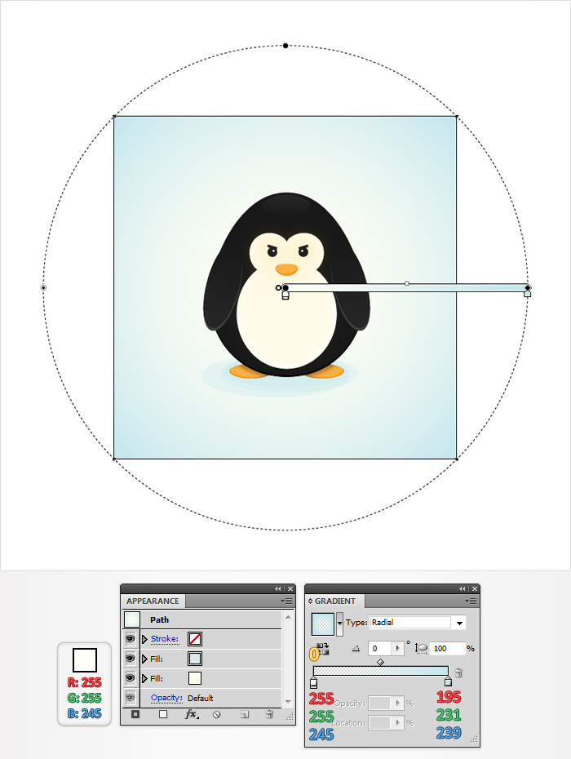
Now your work is done. Here is how it should look like.

